Default style variables are available in root.css, by changing those you should be able to adapt widgets to the page quickly. Each component of widgets has its own possible variables, but defaults to ones defined in root.css. If that’s not enough there’s always the possibility to override styles using css.

Card
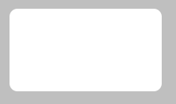
Variable prefix:
--widget-sdk--card-
example (--widget-sdk--card-background)

Tooltip
Variable prefix:
--widget-sdk--tooltip-
example (--widget-sdk--tooltip-background)

variable postfix | card default | tooltip default
background | var(--widget-sdk-background) | var(--widget-sdk-background)
shadow | none | var(--widget-sdk-overlay-shadow)
font | var(--widget-sdk-font) | var(--widget-sdk-font)
border | var(--widget-sdk-border) | var(--widget-sdk-border)
radius | var(--widget-sdk-radius-1) | var(--widget-sdk-radius-1)
padding | var(--widget-sdk-padding-3) var(--widget-sdk-padding-4) | var(--widget-sdk-padding-2)

Modal
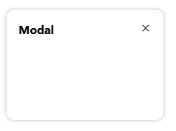
Variable prefix:
--widget-sdk--modal-
example (--widget-sdk--modal-background)

variable postfix | modal default
background | var(--widget-sdk-background)
shadow | var(--widget-sdk-overlay-shadow)
font | var(--widget-sdk-font)
border | var(--widget-sdk-border)
radius | var(--widget-sdk-radius-1)
padding | var(--widget-sdk-padding-4)
gap | var(--widget-sdk-padding-2)

Button

Button (primary)

Variable prefix:
--widget-sdk-button-primary-
example (--widget-sdk-button-primary-background)

Button (outlined)
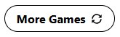
Variable prefix:
--widget-sdk--
example (--widget-sdk--)

variable postfix | primary value | outlined default
background | var(--widget-sdk-highlight) | none
color | var(--widget-sdk-highlight-font) | inherit
border | none | 1px solid currentColor
shadow | none | none
active-background | var(--widget-sdk-highlight) | none
active-color | var(--widget-sdk-highlight-font) | inherit
active-border | none | 1px solid currentColor
active-shadow | none | none

Button (light)

Switch

Switch (primary)
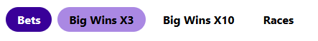
Variable prefix:
--widget-sdk--switch-primary-
example (--widget-sdk--switch-primary-padding)

variable postfix | default value
padding | var(--widget-sdk-padding-1)
radius | var(--widget-sdk-radius-3)
gap | var(--widget-sdk-padding-2)
item-padding | var(--widget-sdk-padding-2) var(--widget-sdk-padding-4)
item-radius | var(--widget-sdk-radius-3)
item-background | var(--widget-sdk-background)
item-color | var(--widget-sdk-input-font)
item-hover-background | var(--widget-sdk-highlight-light)
item-hover-color | var(--widget-sdk-highlight-light-font)
item-active-background | var(--widget-sdk-highlight)
item-active-color | var(--widget-sdk-highlight-font)

Switch (bordered-primary)
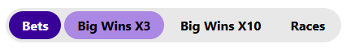
Variable prefix:
--widget-sdk--switch-bordered-primary-
example: (--widget-sdk--switch-bordered-primary-padding)

variable postfix | default value
background | var(--widget-sdk-input-background)
padding | var(--widget-sdk-padding-1)
radius | var(--widget-sdk-radius-3)
gap | var(--widget-sdk-padding-1)
item-padding | var(--widget-sdk-padding-2) var(--widget-sdk-padding-4)
item-radius | var(--widget-sdk-radius-3)
item-background | var(--widget-sdk-input-background)
item-color | var(--widget-sdk-input-font)
item-hover-background | var(--widget-sdk-highlight-light)
item-hover-color | var(--widget-sdk-highlight-light-font)
item-active-background | var(--widget-sdk-highlight)
item-active-color | var(--widget-sdk-highlight-font)

Switch (underlined-primary)
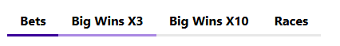
Variable prefix:
--widget-sdk--switch-underlined-primary-
example: (--widget-sdk--switch-underlined-primary-item-padding)

variable postfix | default value
item-padding | var(--widget-sdk-padding-2) var(--widget-sdk-padding-4)
item-line-height | 3px
item-line | var(--widget-sdk-lowlight)
item-line-hover | var(--widget-sdk-highlight-light)
item-line-active | var(--widget-sdk-highlight)

Select
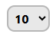
Variable prefix:
--widget-sdk--select-
example: (--widget-sdk--select-color)

variable postfix | default value
color | var(--widget-sdk-input-font)
background | var(--widget-sdk-input-background)
padding | var(--widget-sdk-padding-1)
border | var(--widget-sdk-input-border)
radius | var(--widget-sdk-radius-1)
active-border | var(--widget-sdk-input-active-border)

Table

Table (lowlight)

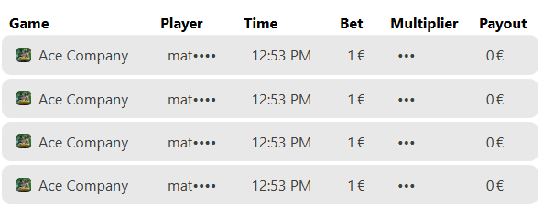
Variable prefix:
--widget-sdk--tbllleo-
example: (--widget-sdk--tbllleo-head-background)

Table (lowlight-even-odd)

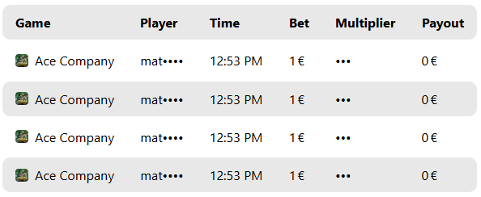
Variable prefix:
--widget-sdk--tblll-
example: (--widget-sdk--tblll-head-background)

variable postfix | lowlight default | lowlight-even-odd default
head-background | none | var(--widget-sdk-lowlight)
head-color | inherit | inherit
head-padding | 0 var(--widget-sdk-padding-2) | var(--widget-sdk-padding-3) var(--widget-sdk-padding-4)
head-radius | var(--widget-sdk-radius-1) | var(--widget-sdk-radius-1)
item-background | var(--widget-sdk-lowlight) | var(--widget-sdk-lowlight)
item-color | var(--widget-sdk-font-light) | inherit
item-padding | var(--widget-sdk-padding-3) var(--widget-sdk-padding-4) | var(--widget-sdk-padding-3) var(--widget-sdk-padding-4)
item-radius | var(--widget-sdk-radius-1) | var(--widget-sdk-radius-1)
item-spacing | var(--widget-sdk-padding-1) | var(--widget-sdk-padding-1)
item-odd-background | var(--widget-sdk-lowlight) | none
small-font | var(--widget-sdk-font-md) | var(--widget-sdk-font-md)
small-item-padding | var(--widget-sdk-padding-2) var(--widget-sdk-padding-1) | var(--widget-sdk-padding-2) var(--widget-sdk-padding-1)

